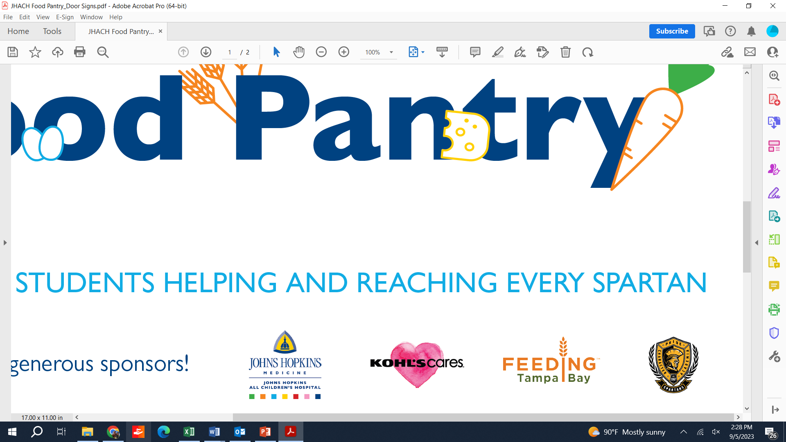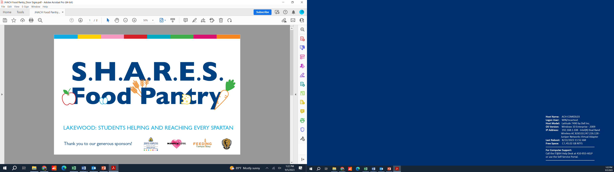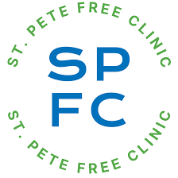

Each Friday, students have the opportunity to pick up fresh produce, protein, baked goods, and pantry staples from the Lakewood SHARES food pantry to take home.

In addition to food items, the pantry is stocked with clothing, personal hygiene items, and other school supplies.

The Spartans SHARES pantry is open each Friday immediately after school from 1:50 – 2:15pm. Students in need outside that time may visit Mrs. Dickerson.

If you would like receive more information about the pantry, please scan the QR code and fill out the survey.